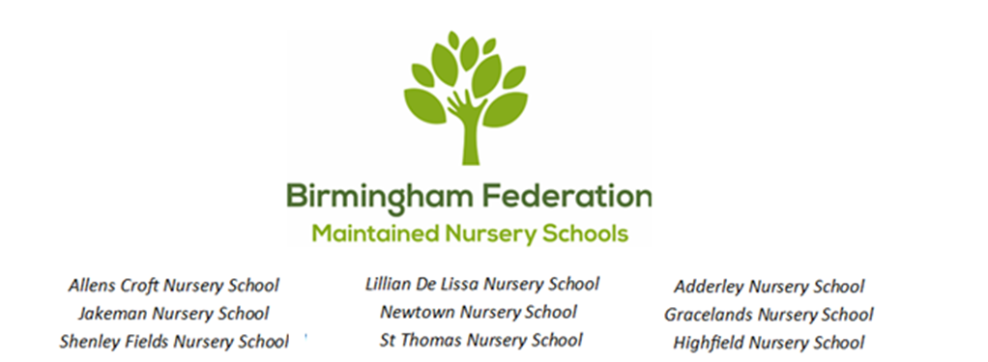

Learning Outside the Classroom (LOTC) Policy

What is LOtC?
Learning Outside the Classroom (LOtC) is the use of places other than the classroom for teaching and learning. It is about getting children and young people out and about, providing them with challenging, exciting and different experiences to help them learn.

The places where learning happens can have a significant effect on how a young person engages with a subject or an idea. Learning outside the classroom can happen at almost any time and almost anywhere – outdoors or indoors: in the school grounds, the local shops, the park, the library, the farm, the zoo and with visitors to the nursery.

Aims
- To introduce pupils to a range of new experiences
- To develop the curriculum through using the local environment and community
- To offer pupils exciting and stimulating experiences that enthuse them in their learning
- To develop self-esteem through providing a range of opportunities for pupils to excel
- For pupils to develop their social skills, independence and resilience through the experiences we offer

Forest School
Forest school encourages children to explore their own innate learning in the richest classroom we have – the outdoors. The forest school ethos focuses on an approach to learning that maximizes the emotional, social and developmental benefits of education.
Forest school is run by trained forest school leaders, together with other staff who are well versed in the forest school process.

Forest school sets learning in a different context for children where they can undertake a range of practical activities and carry out small achievable tasks. At forest school, children can develop their team working skills and also learn to
become more independent. Those who are unfamiliar with woodlands and green spaces can become confident in using them and this can form the basis of a life-long relationship with natural spaces.

Use of School Garden/ Grounds
Outdoor learning is an integral part of what we do at Shenley Fields Daycare and Nursery School as it can offer so many experiences and learning opportunities for our children. We know that for some children the opportunities they have to spend time in the outdoors is limited, and through our knowledge of each individual child we can offer a range of experiences that add to and enhance their cultural capital as they learn and grow with us.

At Shenley Fields we offer daily opportunities to:

- Take part in forest school activities with our forest school leaders
- Be physically active outdoors
- Take part in gardening activities and visits to the allotment
- Mud kitchen
- Outdoor stories and imaginary play
- “Shenley Sweepers” litter picking
- Grow to eat gardening groups
- Outdoor studio
- Sensory garden
- Recycling

The Local Community

- Forest school sessions for all the family in the local park
- Visits to the post office
- Walks to the post box to post letters
- Visits to the grocery shop to buy ingredients for cooking activities
- Visits to the café
- Visits to the hairdressers
- Walks around our local area to support children’s interests and learning.

These experiences provide safe, engaging, and educational opportunities that help children grow into active members of their local community.

Children visiting local community shops fosters essential life skills, including financial literacy, social interaction, and confidence, while building a sense of belonging and community pride

Shopping locally and growing our own fruit, vegetables and herbs also helps to reduce the nursery schools carbon footprint.

Visitors

- Parents and family members to share skills
- Fit 4 Sport
- Nurse
- Fire Service
- Musicians
- Storytellers

Visiting professionals to nursery such as fire fighters, police officers, dentists, or nurses, offer significant developmental and educational benefits for young
children. It helps children recognise trusted adults, learn safety rules (e.g. fire safety), and understand who to ask for help in an emergency, often making them feel safer. These visits to nursery give the children the opportunity to ask questions and participate in hands-on activities, such as trying on a uniform or exploring equipment. Interacting with diverse visitors to nursery supports the children’s communication, active listening, and curiosity.

Trips and Visits
It is expected that all age groups at Shenley Fields Daycare and Nursery School have at least two trips during the school year. These will be included in the curriculum plans and will support and expand opportunities for teaching and learning. Trips and visits should:

- Be part of the curriculum and enhance teaching and learning
- Provide hands-on, stimulating opportunities for pupils
- Be with quality badge providers wherever possible
- Help develop social skills and self-esteem

Risk Assessment
Shenley Fields Daycare and Nursery School risk assessment process is designed to manage real risks when planning trips whilst ensuring that learning opportunities are experienced to the full. The Educational Visits Co-Ordinator initially draws up a visit plan and timetable (who, what, where, why, when and how?) Trip leaders will read trip risk assessments, visit plan and time table for the day, approved by SLT and the Executive Headteacher. A risk assessment visit should be made by the group leader prior to the visit of the group.

The risk assessment process is as follows:
- Identify the hazards
- Decide who might be harmed and how
- Evaluate the risks and decide on precaution
- Record your findings and implement them
- Review your assessment and update if necessary

First Aid
On any visit, at least one of the supervisory staff will be a competent First Aider, holding a valid first-aid certificate and carrying an appropriate first-aid kit.

Monitoring and Evaluation
In order to monitor and evaluate this offer SLT and practitioners will:

- Monitor and evaluate plans termly for trips, visits and visitors
- Monitor and evaluate plans fortnightly for opportunities and experiences for children Learning outside the classroom.
- All pupils are fully able to participate in forest school, visitors, trips, visits and Learning outside the classroom.
- Experiences support and develop curriculum plans
- Learning outside the classroom experiences are evaluated for their effectiveness. In addition, experiential audits confirm the experiences that all pupils take part in throughout each half term. These are analysed, based on vulnerable groups (e.g. SEN, FSM, boys/ girls, EAL), discussed and evaluated to SLT and practitioners to identify and measure the involvement and experiences each child participates in throughout school life.

United Nations Convention on the Rights of the Child (UNCRC)
This also links to our Rights Respecting Schools (RRS) ethos:

Article 15: Every child has the right to meet with other children and to join groups and organisations, as long as this does not stop other people from enjoying their rights.
Article 28: Every child has a right to an education.
Article 29: Education must develop every child’s personality, talents and abilities to the full.
Article 31: Every child has the right to relax, play and take part in a wide range of cultural and artistic activities.

Linked Policies:
Safeguarding & Child Protection
Long Term Curriculum Document/ Policy
Health & Safety
Educational Visits

Date Policy Adopted:
Local Committee: 23.03.2026
Full Governing Body: 27.4.2026
Date for Next Renewal: Spring Term 2028

Signed: ____________________________ Sally Andrews
Chair of Local Committee

Signed: ____________________________ Sean Delaney
Chair of Governors

Signed: ____________________________ David Aldworth
Executive Head Teacher

